1. select*from emp;

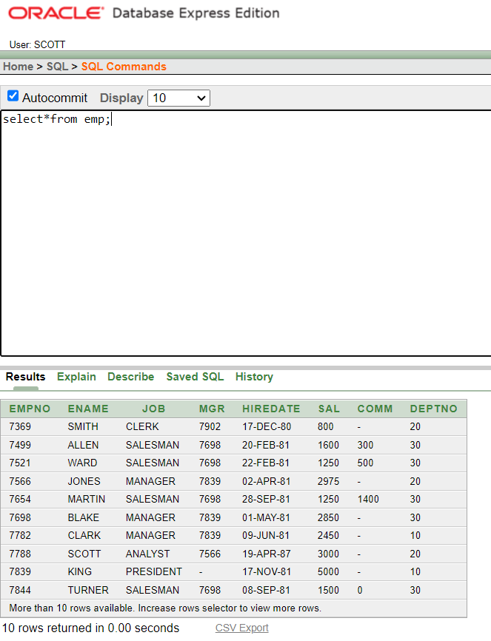

1. select *from dept;

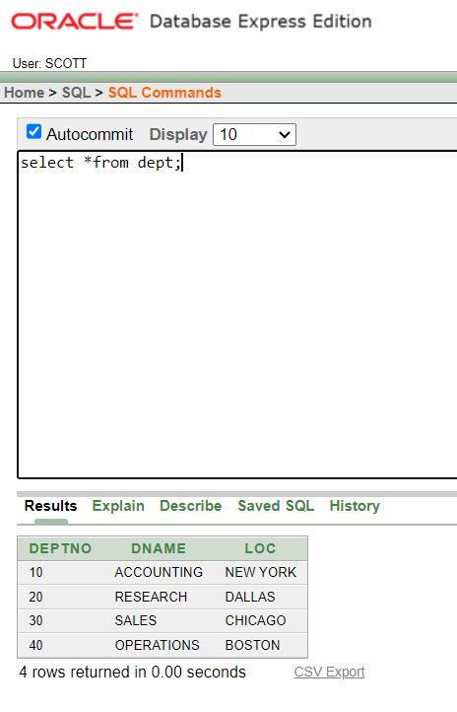

1. select deptno,loc from dept;

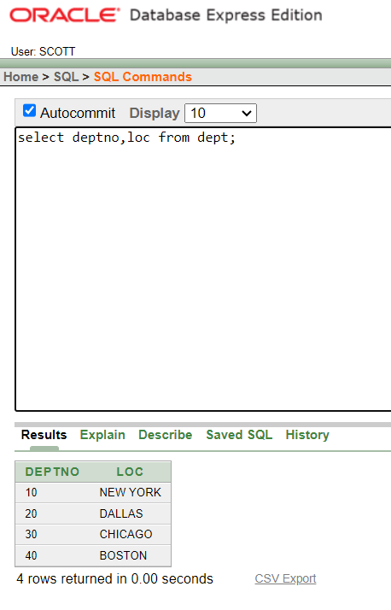

1. select ename,sal,sal+300 from emp;

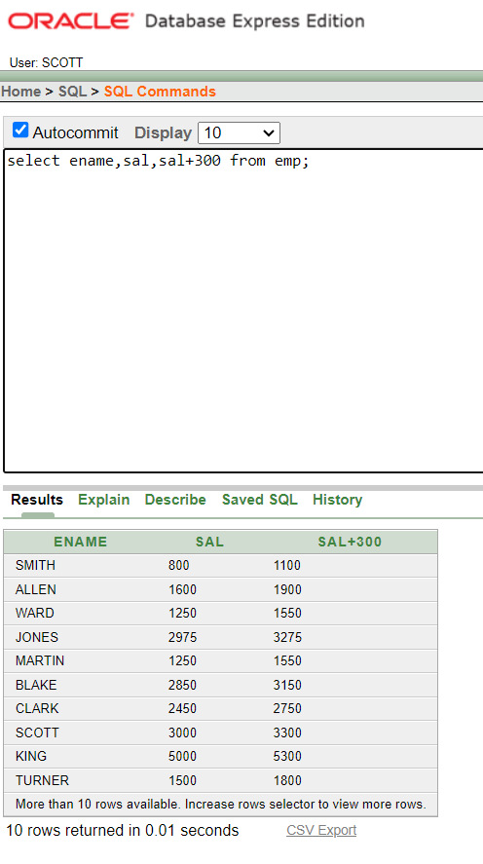

1. select ename, sal, 12*sal+100 from emp;

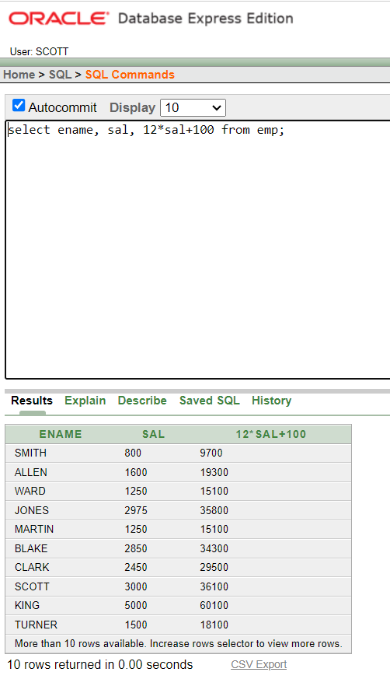

1. Select ename,sal,12*(sal+100)from emp;

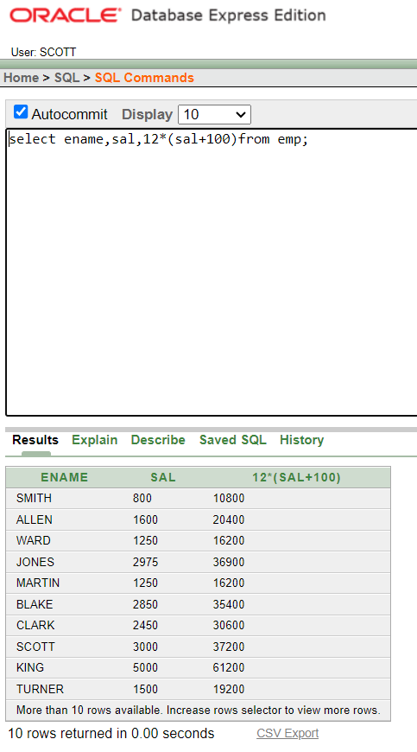

1. select ename, job, comm from emp;

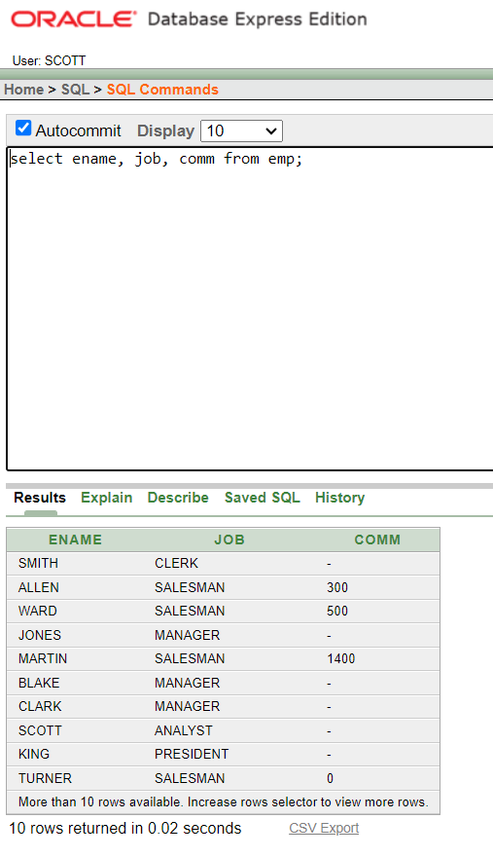

1. select ename, 12*sal+comm from emp where ename='KING';

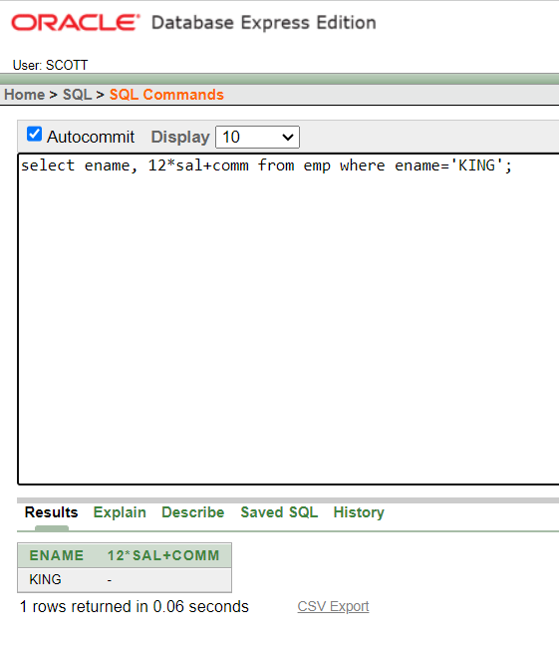

1. select ename as name,sal salary from emp;

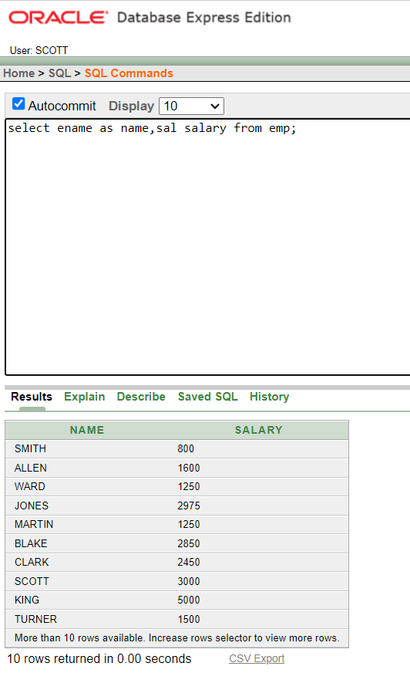

1. select ename "Name",sal*12 "Annual Salary" from emp;

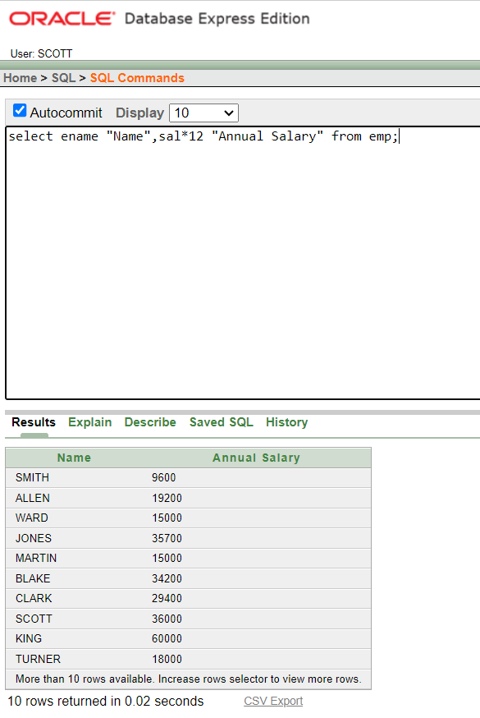

1. select ename||job as "Employees" from emp;

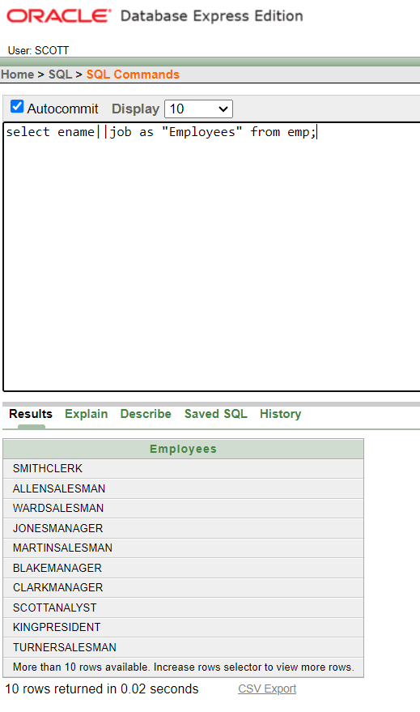

1. select ename||' '||'is a'||' '||job as "Employee Details" from emp;

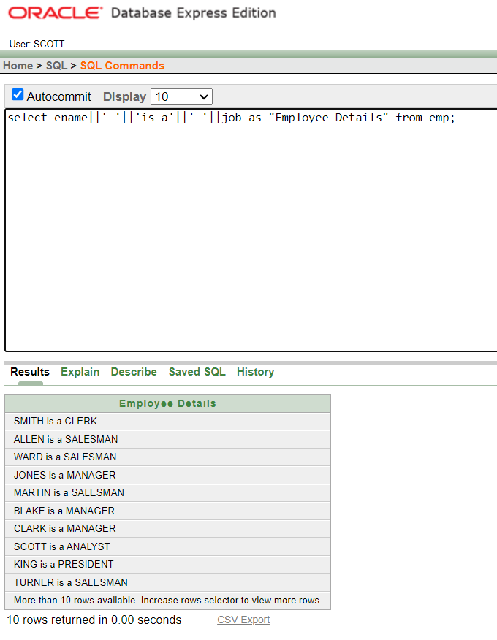

1. select deptno from emp;

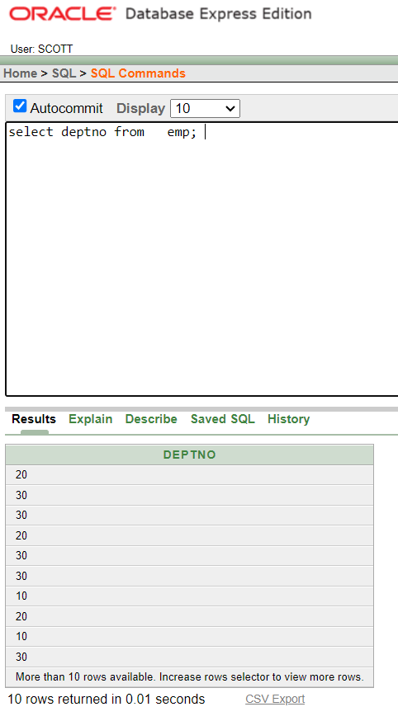

1. select DISTINCT deptno from emp;

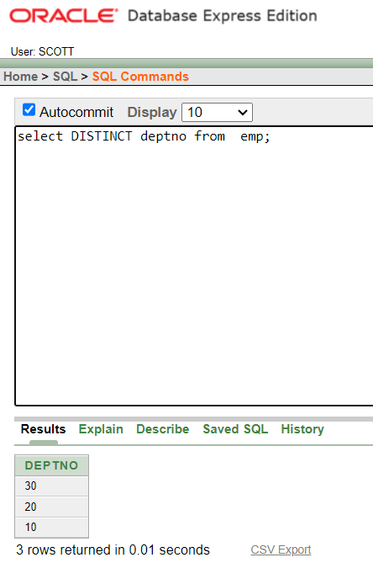

1. DESCRIBE dept

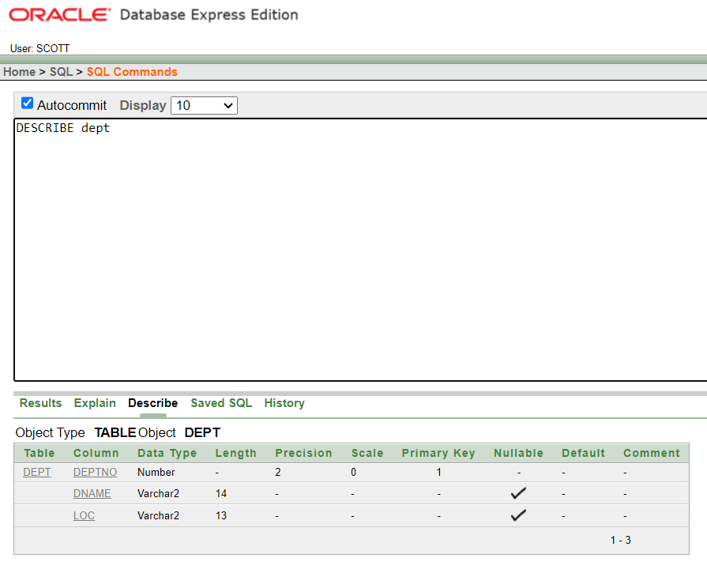

1. select ename,deptno from emp;

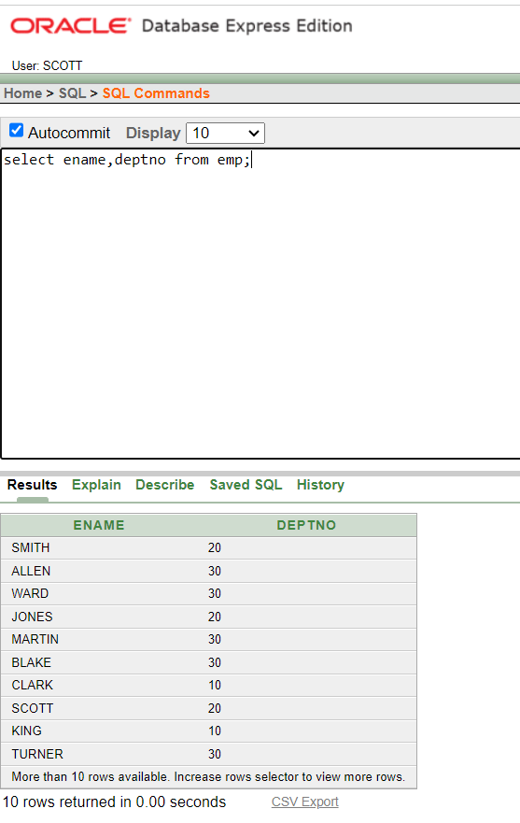

1. select distinct job from emp where deptno= 30;

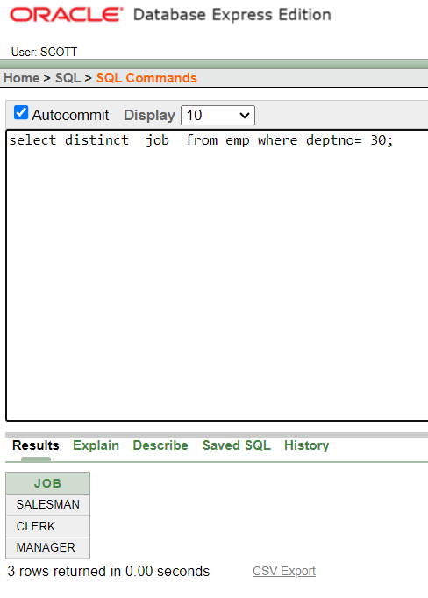

1. select loc from dept where deptno= 30;

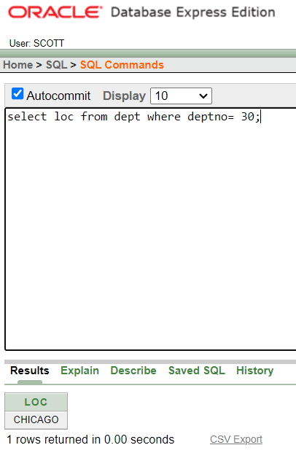

1. select ename,empno from emp where comm>0

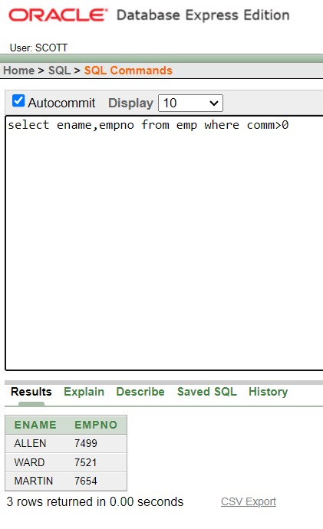

1. select ename,deptno from emp where ename like 'A%' or ename like '_A%' or ename like '_A%';

